CONFIDENTIAL CS/NOV 2026/MAT133

UNIVERSITI TEKNOLOGI MARA
MARKING SCHEME

COURSE
COURSE CODE
EXAMINATION TIME
PRE CALCULUS
MAT133 NOVEMBER 2026
2 HOURS

INSTRUCTIONS TO MARKERS

- This marking scheme accompanies the MAT133 mock paper (November 2026).

- Answers and marking points are for local study use only.

FOR MARKERS' USE ONLY

This marking scheme consists of 6 printed pages

NO | SOLUTION | MARK
1 a) | 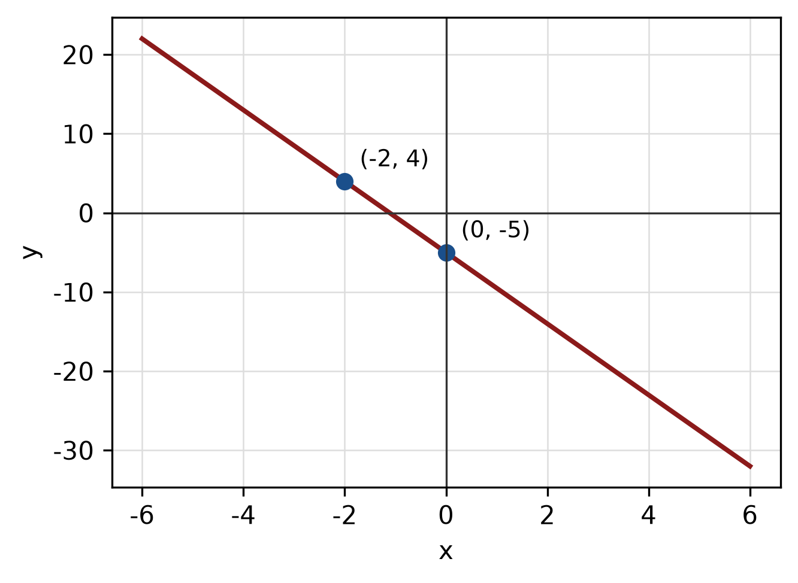 | 4 m
  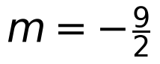 | M1
  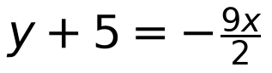 | M1
  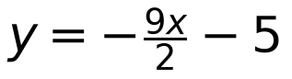 | A1
1 b) | 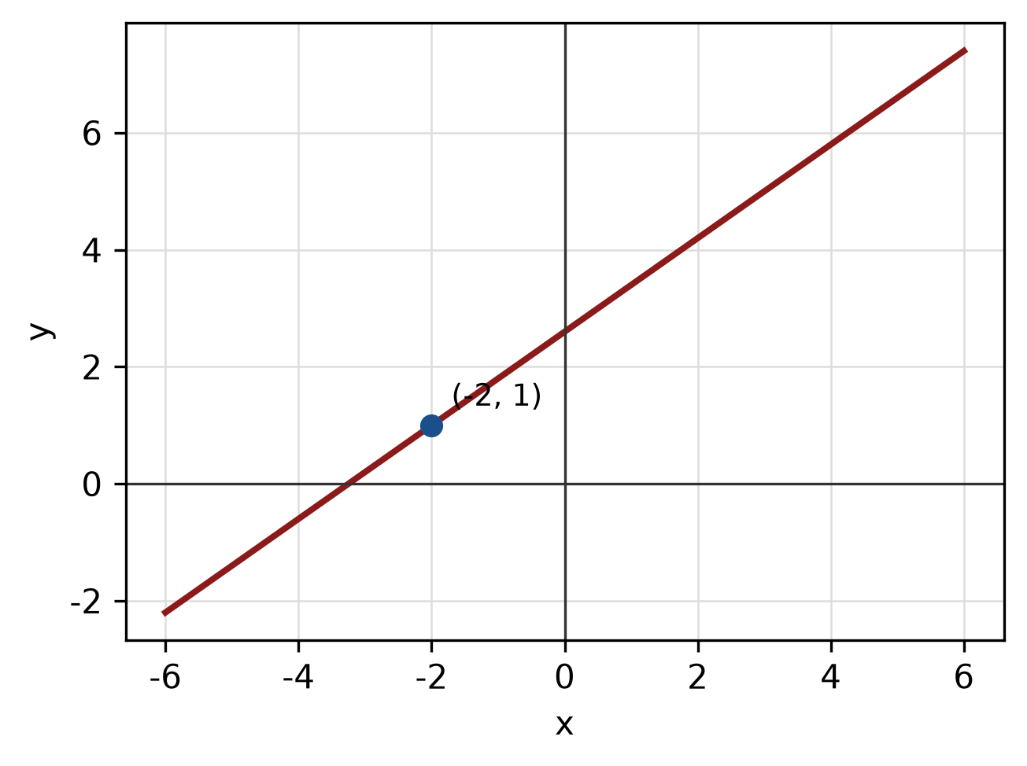 | 5 m
  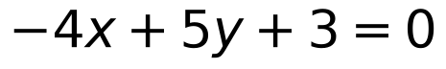 | M1
  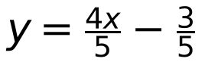 | M1
  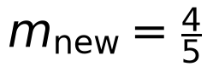
  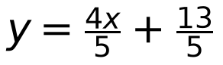 | A1
1 c) | 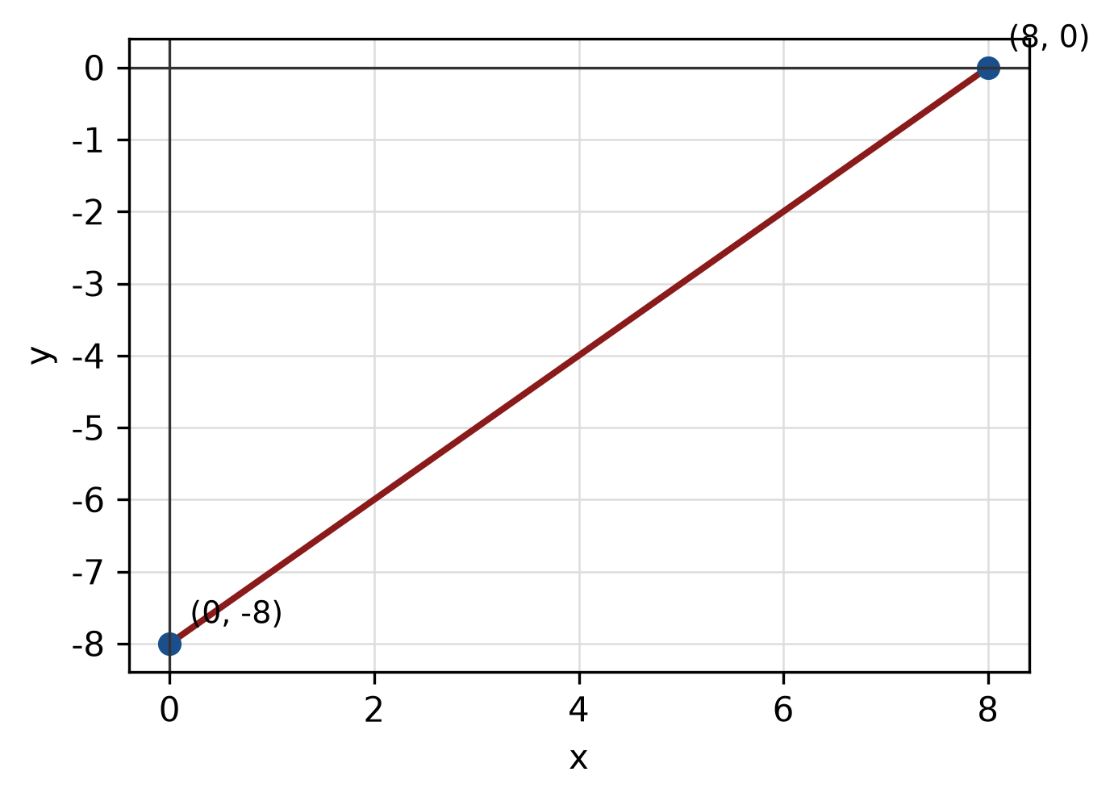 | 4 m
  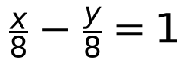 | M1
  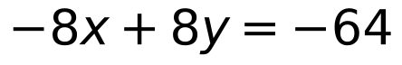
  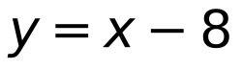 | A1
2 a) | 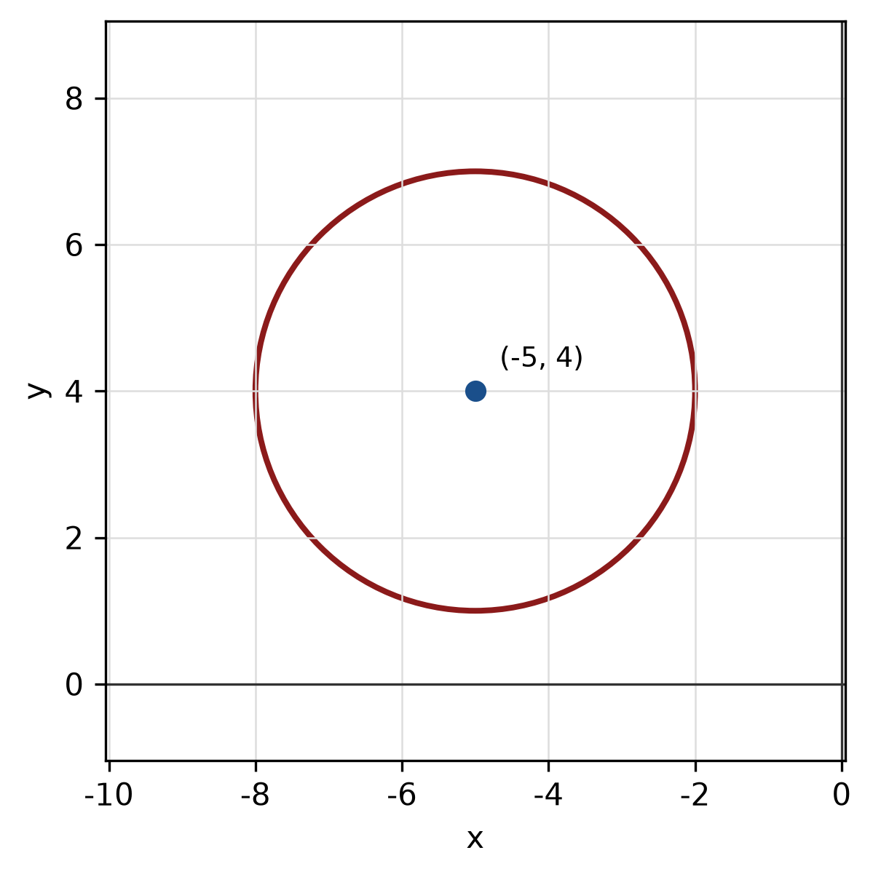 | 5 m
  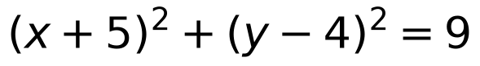 | M1
  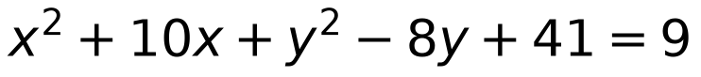 | A1
  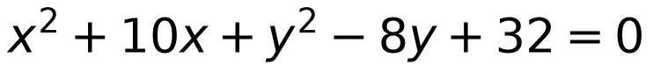 | B1
2 b) | 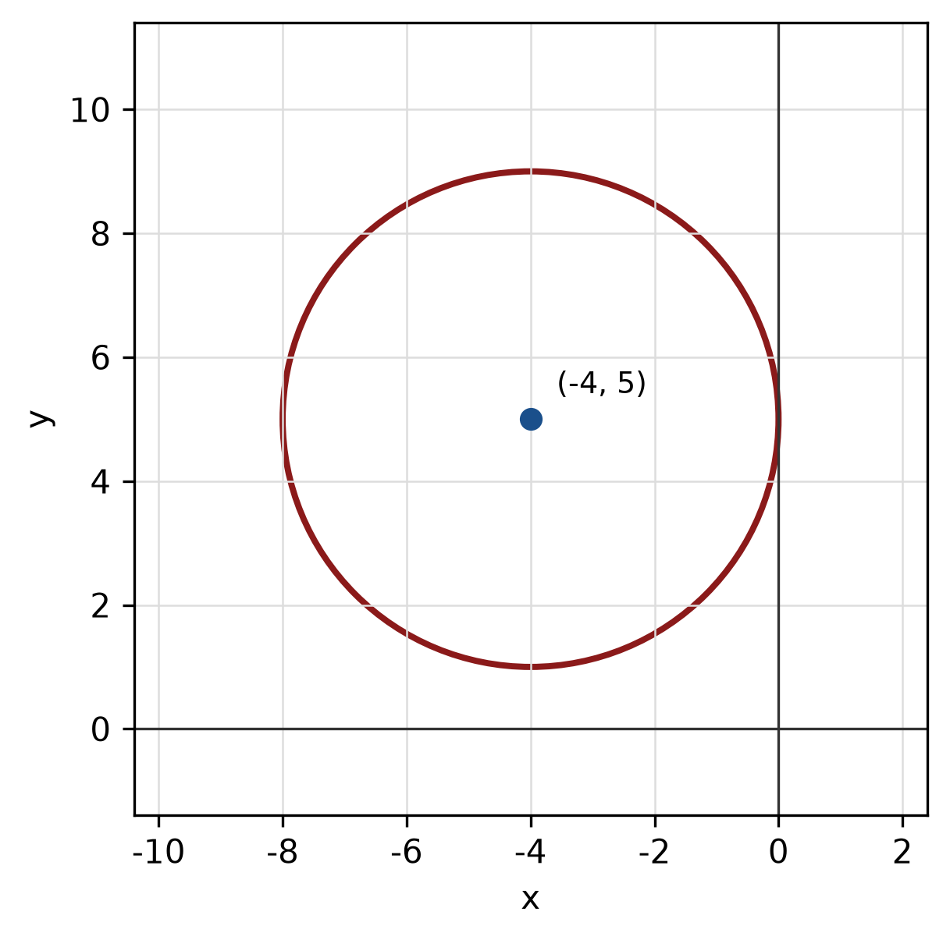 | 5 m
  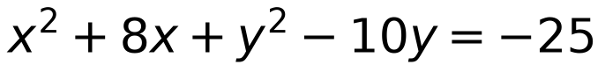 | M1 M1
  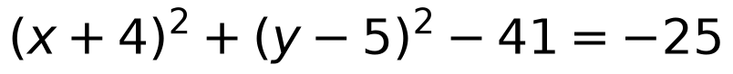 | A1
  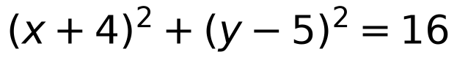 | A1
2 c) | 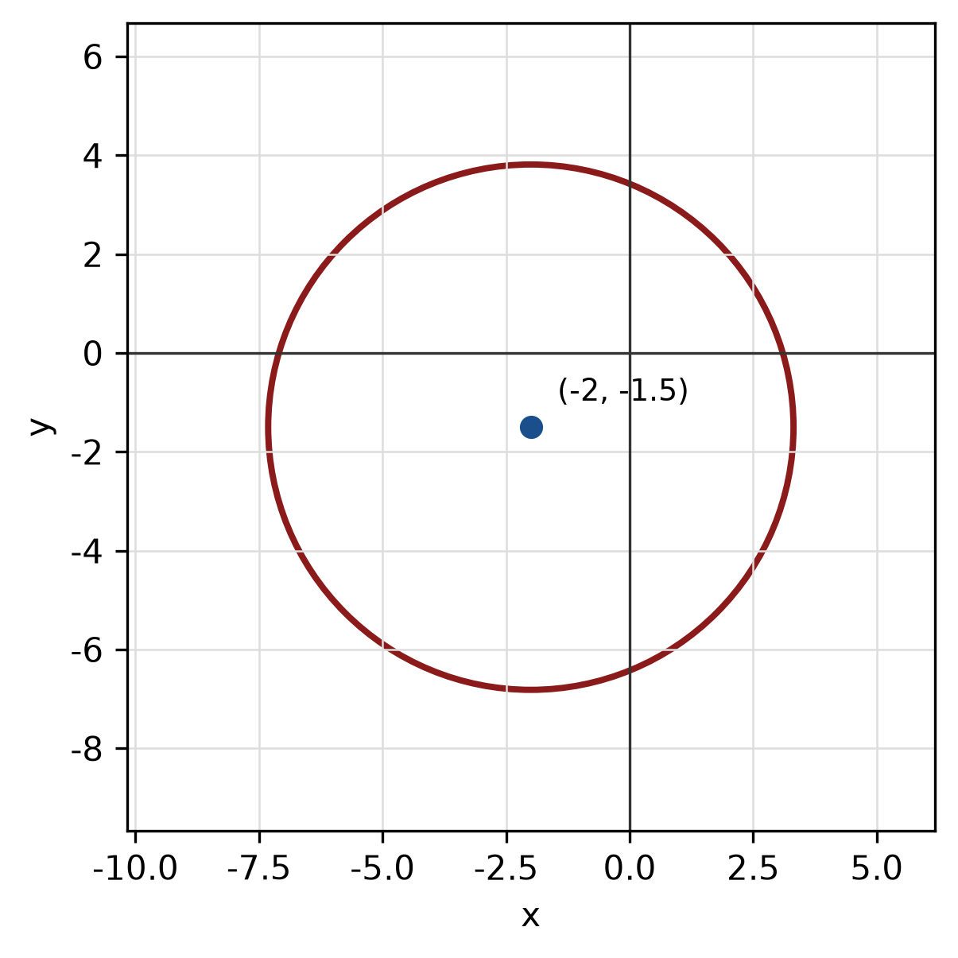 | 5 m
  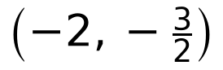 | M1
  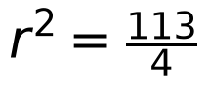 | M1
  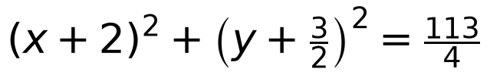 | A1
2 d) | 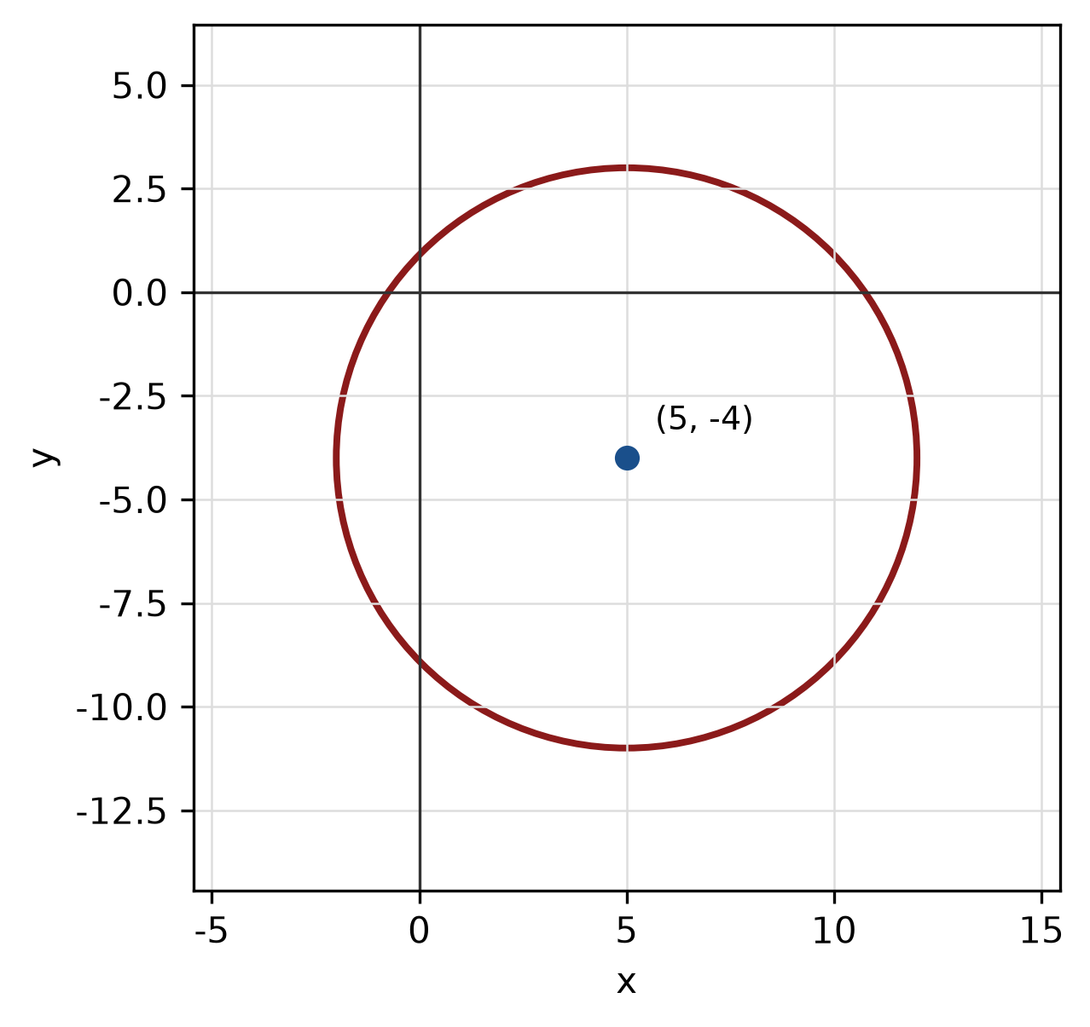 | 4 m
  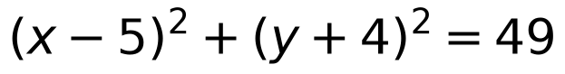 | M1 A1
  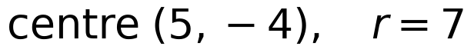 | A1
3 a) | 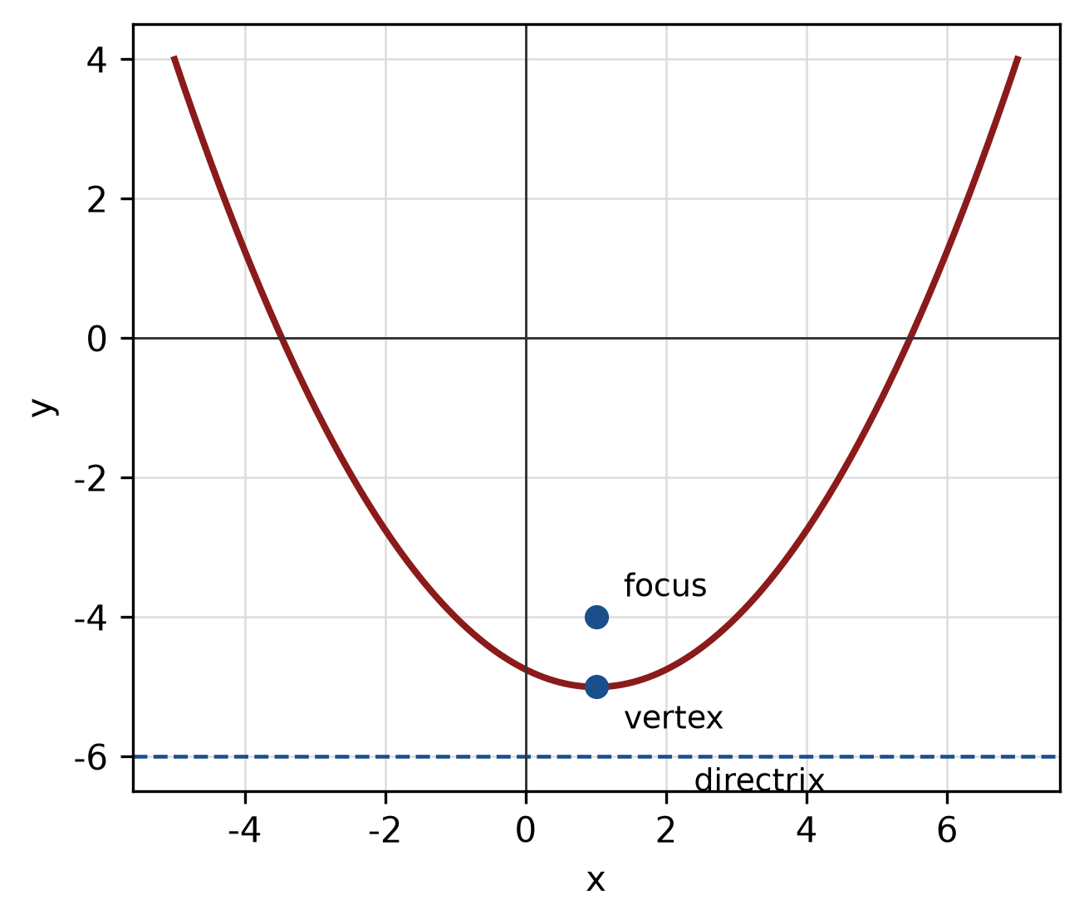 | 5 m
  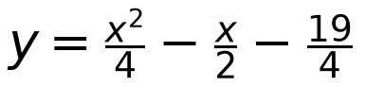 | M1 A1
  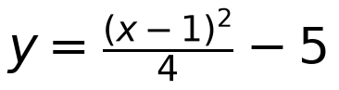 | A1
  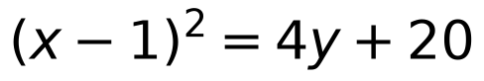 | A1
3 b) | 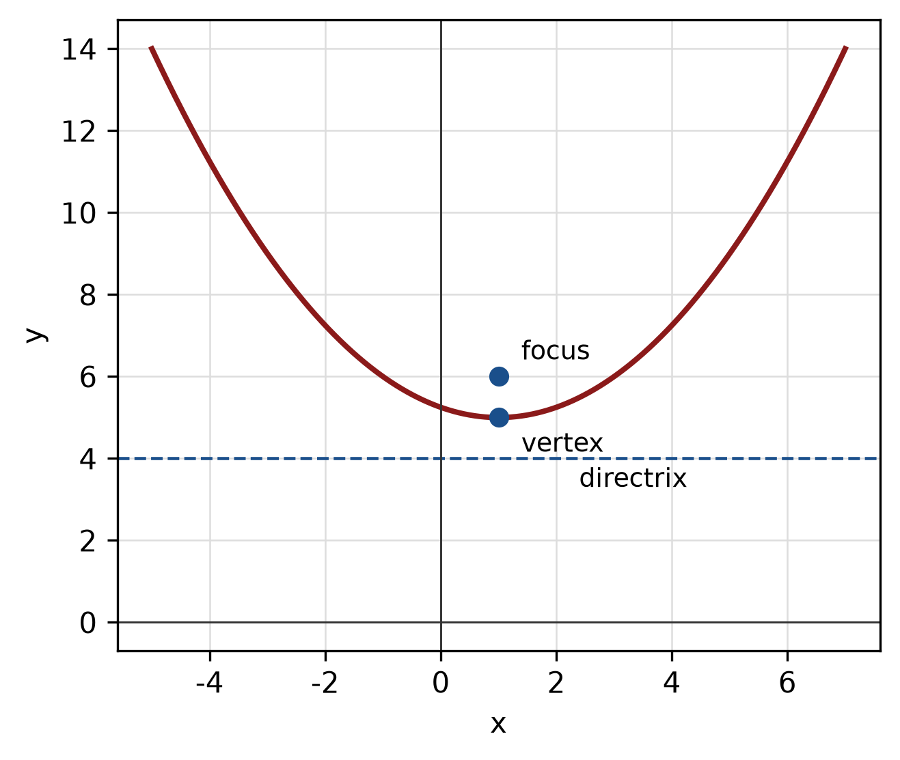 | 5 m
  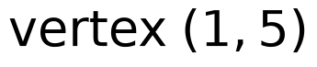 | M1
  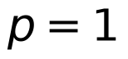 | M1
  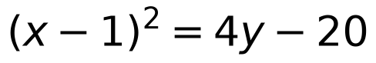 | A1
3 c) | 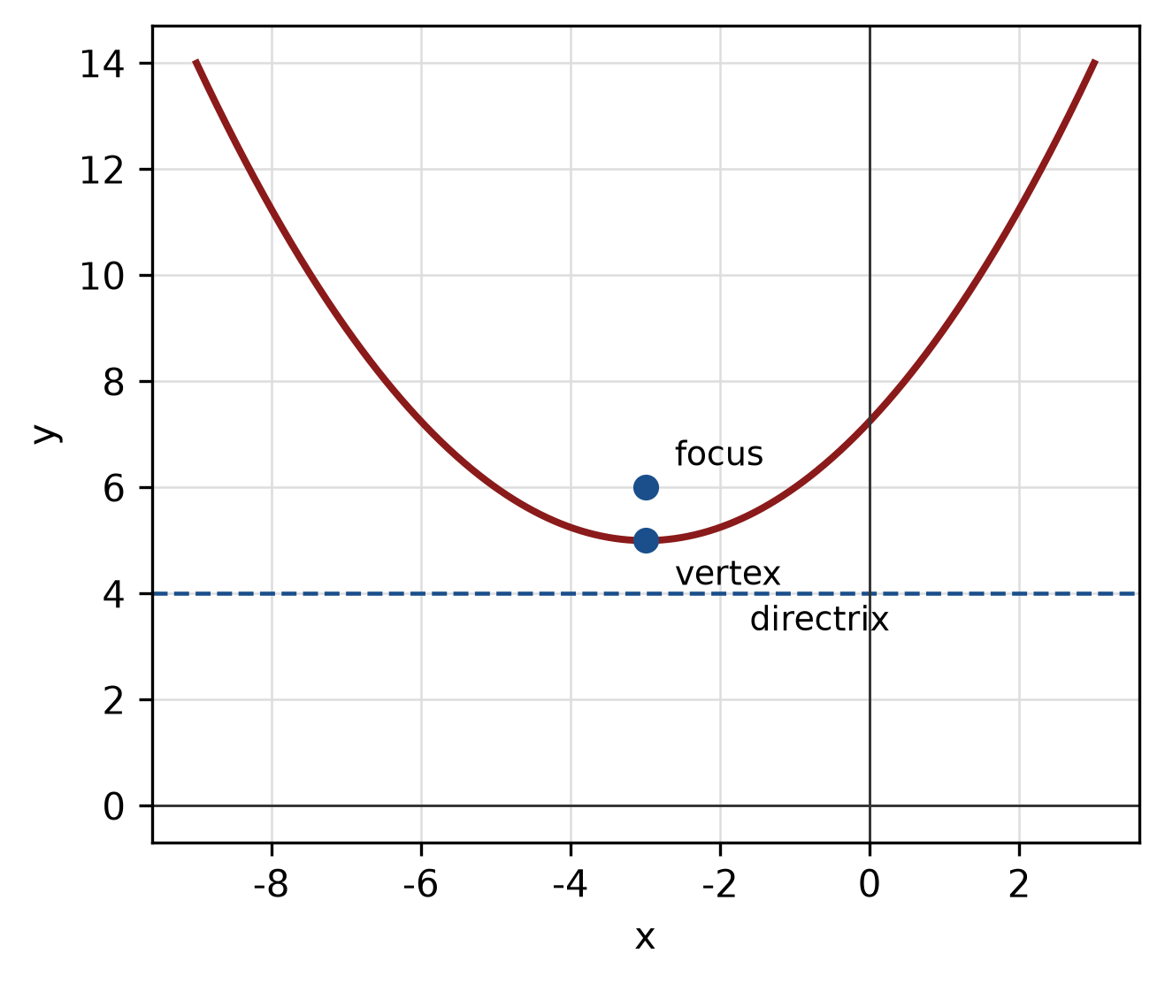 | 5 m
  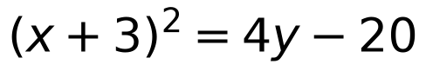 | A1
  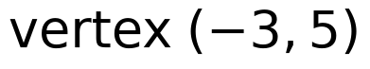 | A1
  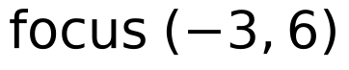 | A1
  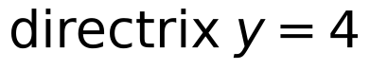 | B1

